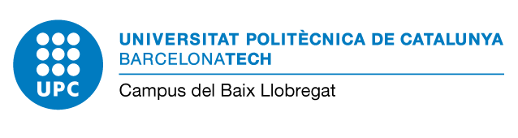
Edifici D7 - C/Esteve Terradas, 10
08860 Castelldefels (Barcelona)
Campus Baix Llobregat - Parc Mediterrani de la Tecnologia

Student’s Full name:

ID number / Passport number:

Authorised person (if needed/in case of) :___________________________________________________

Degree studying:
School: EETAC ESAB
Address (to notify effects)

Address: City/Town: Postcard Code: Province:
E-mail address:

Telephone/ Mobile Numbers:

Request for: __________________________________________________________

Reason:

Documents presented (you must submit in this moment):

I give my consent to the UPC for the handing of the personal data collected in the reverse of this document.

Signature:

Full name: Place and date:

1/2
MS./MRS./MR. DIRECTOR OF THE EETAC MS./MRS./MR. DIRECTOR OF THE ESAB

Information about data protection
Responsible of data processing | Universitat Politècnica de Catalunya  Campus del Baix Llobregat  https://cbl.upc.edu/ca  cbl.proteccio.dades@upc.edu
Contact details of the data protection officer | Universitat Politècnica de Catalunya  https://www.upc.edu/normatives/ca/proteccio-de-dades/normativa-europea-de-proteccio-de-dades/dades-de-contacte-del-delegat-de-proteccio-de-dades
Purposes of data treatment | F03.13 Gestionar de forma multicanal el servei d'informació i l'atenció a les persones que contacten amb aquesta Universitat.  https://www.upc.edu/normatives/ca/proteccio-de-dades/registre-de-tractaments-de-dades-personals/F03.13  Provide information and attention to the people who contact the Teaching Support Office of the Baix Llobregat Campus.
Laws of data processing: | (Consentiment)  The data subject has given consent to the processing of his or her personal data for one or more specific purposes  https://www.upc.edu/normatives/ca/proteccio-de-dades/normativa-europea-de-proteccio-de-dades/legitimacio
Transfer of personal to third parties | Your data will not be communicated to third parties, unless there was a legal obligation.
Data subject’s rights | (Sol·licitar l’accés. La rectificació o supressió. La limitació del tractament. Oposar-se al tractament. Portabilitat de les dades.)  Right of access by the data subject, Right to rectification, Right to erasure (‘right to be forgotten’), Right to restriction of processin, Right to data portability  https://www.upc.edu/normatives/ca/proteccio-de-dades/normativa-europea-de-proteccio-de-dades/drets
Retention Policy: | (Mentre sigui necessari per a qualsevol dels propòsits que es descriuen a la nostra política de conservació)  The collected and processed personal data will be kept as needed for any of the purposes described in our retention policy.  https://www.upc.edu/normatives/ca/proteccio-de-dades/normativa-europea-de-proteccio-de-dades/politica-de-conservacio-de-les-dades-de-caracter-personal
Complaint | If you have not been satisfied with the exercise of your rights you can file a complaint with APDCAT: apdcat.gencat.cat

2/2

